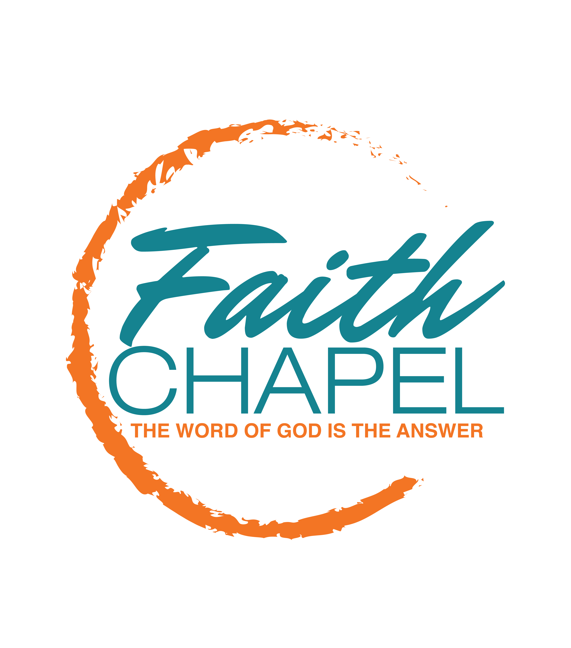

Production Ministry Request

Please submit to: production@faithchapel.net

Today’s Date:

Contact Info
Your Name: Your Title:
Your Ministry:
Daytime Phone Number Evening Phone Number
Email Address:

Additional Contact Person:
Daytime Phone Number: Evening Phone Number:
Email Address:

Location Info
Date of Event: Time of Event:
Name of Event:
Type of Event:
Location of Event:
If this is an off-campus Click here if not applicable
event, please include
physical address
Off-campus location phone Click here if not applicable
number
Off-campus location contact Click here if not applicable
person

Event Info
Number of expected guest and attendees:
Who will be ministering or speaking?
Will you need a clock or timer? (if so, please provide timing instructions) Yes No
Will there be any special invited guests? Yes No
If so, who?
Please provide special guest information, contracts, and performance riders along with this form.

Will there be a dress rehearsal? Yes No
Date(s) of dress rehearsal(s) Time(s) of dress rehearsal(s)
Will event need be audio or video recorded or both? Yes No

How many Hand Held Microphones? How many lavaliere microphones?
Additional Comments and
pertinent information:

Please submit your event agenda or program schedule along with this form. All requests have to be made 30 calendar days before the date of the event. The Production department must be notified in writing in the event of changes to or deviations from this original request. All outside events must have a sound check scheduled 5 hours before the start of the event. All major productions must include rehearsal times. Submission of this form does not guarantee service.

Rev 02/2017

